High Street, Sittingbourne, ME10 4AQ
Tel: 01795 423196
www.sbc-church.org.uk/sittingbourne-contact-centre
contact.centre@sbc-church.org.uk

Sittingbourne Baptist Church

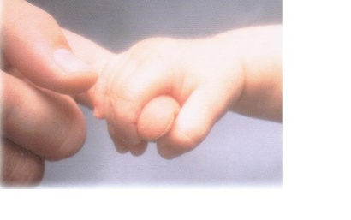

CONTACT CENTRE

RE: THE TAKING OF PHOTOGRAPHS AND USINE OF VIDEO/DIGITAL CAMERA’S AT THE CENTRE.

Due to recent enquiries we are reminding all those who use the Contact Centre of the rule no 8 in our referral documents that you were instructed about before using of the centre.

8. Parents must speak to one of the volunteer helpers before taking photographs or using a video/digital camera at the Centre. The privacy of other families must be respected.

Any person not respecting this rule and found to be using the above without permission of the centre staff may forfeit the right to use our facilities.

